|  |  |
| --- | --- |
| **Process Name:** | Generating Student Attendance: Quick Export |
| **Last Updated:** | 5/08/2017 9:43 AM |
| **Initial Author:** |  |
| **Last Updated by:** | Cynthia Gilks MacInnis (ASD N) |
| **Time period(s) most often used:** | September to June |

**Generating Student Attendance: Quick Export**

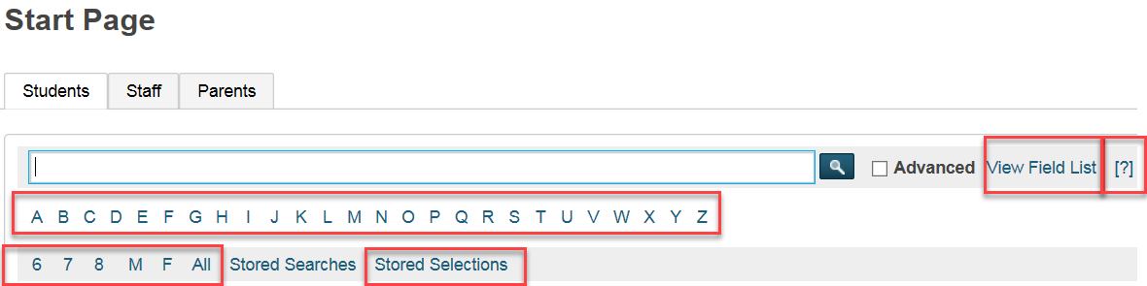This task involves a working knowledge of Power School and Excel. Visual instructions which show how to use both Power School and Excel to do a Quick Export can be found in the video folder of Data Connect titled: *Creating a Customized List Using Quick Export*. Otherwise, **users who are competent in exporting data to Excel will find the following narrative sufficient to do the job.

1. Select a list of Students on the Start Page using a variety of techniques (Ex. All, By Grade Level or use Filters to collect the data)
2. Terms and Codes are explained as follows:

*Search Argument:* The data you want (Example: students in 7S Homeroom) - *view Field List*

*Comparator*: The way the data is manipulated or compared against itself (example: contains) – *(?)*

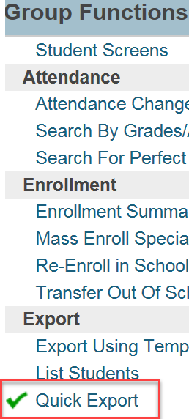*Field Name*: The specific data being manipulated (example: Home_Room) – *view Field List*

1. Launch Quick Export: Start Page>Group Function> Quick Export

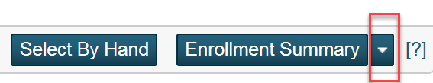

1. In Quick Export you will continue to select the fields and enter the codes to get the data you want. Then click *Submit*

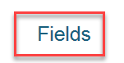

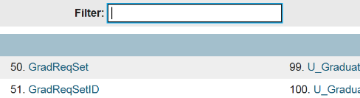Choose Field Names to Export: The example shows the use of student_number, lastfirst, Home_Room and the DABS code which is explained below:

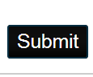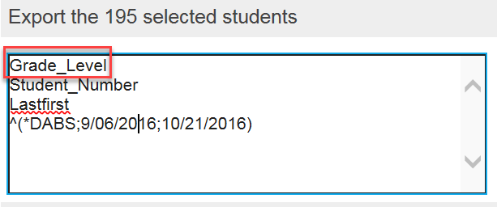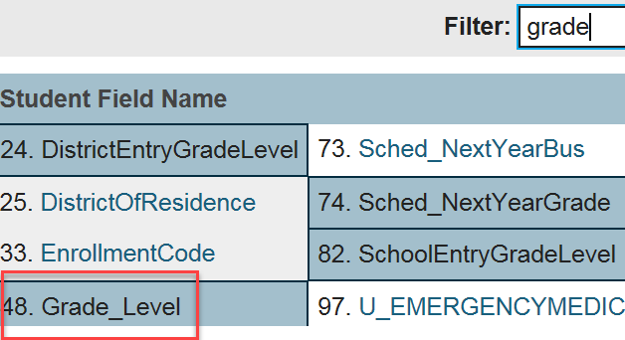

In matters **related to Attendance you** will need the following codes:

* For Absences use ^(*DABS,insert date range)
* For Tardies use ^(daily.att.count ;;tar, insert date range as you would for absences)
* Date range is entered as such 9/08/2015;11/13/2015). A semi colon separates the start and end dates in your search. A closing bracket is applied at the end of the second date.

1. After the fields are generated the list will be populated in Quick Export. Click Submit. The document will then need to be saved as and then open with Excel. Once in Excel the document can be manipulated as per the functions of the software.
2. As a reminder: The video, *Creating a Customized List Using Quick Export*, provides a tutorial on how to use the Excel software to manipulate data. The video is located on Data Connect in the videos folder.